Task 11.2 - Supply Chain & Inventory -
Track raw material levels, lead times, stock-outs, and vendor performance.

Introduction
The objective of this dashboard is to provide a clear and actionable overview of inventory performance across warehouses, categories, and suppliers. It helps stakeholders monitor stock health, demand accuracy, supplier reliability, and inventory value to support better planning and decision-making.

Key Performance Indicators (KPIs)
Total Inventory Value - 1.26M
- Represents the total monetary value of inventory currently held.
- Indicates how much capital is tied up in stock.
- High value requires careful monitoring to avoid excess holding costs.

Low Stock Items - 241
- Shows the number of SKUs with low inventory levels.
- These items may require immediate reorder to prevent stock-outs.
Average Daily Sales - 2.66K
- Reflects overall daily demand across SKUs.
- Helps align inventory planning with actual consumption.
Average Demand Forecast Accuracy - 78.97%
- Indicates how accurate demand predictions are.
- A value close to 80% shows reasonably reliable forecasting, but still has room for improvement.
Supplier On Time % - 84.67%
- Measures how often suppliers deliver orders on time.
- A good indicator of supplier reliability, which directly impacts inventory availability.

Inventory Status Distribution (Donut Chart)
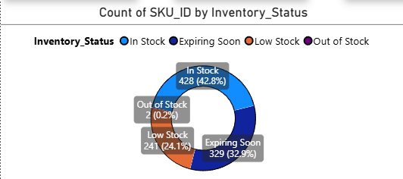

This chart shows how SKUs are distributed across different inventory conditions:
- In Stock (42.8%) - Healthy inventory levels with no immediate risk.
- Expiring Soon (32.9%) - Significant portion of inventory needs attention to avoid wastage.
- Low Stock (24.1%) - Nearly one-fourth of SKUs are at risk of stock-out.
- Out of Stock (0.2%) - Minimal but critical items requiring urgent replenishment.
Insight: The high percentage of Expiring Soon and Low Stock items highlights the need for better demand planning and inventory rotation.

Inventory Value by Category (Treemap)
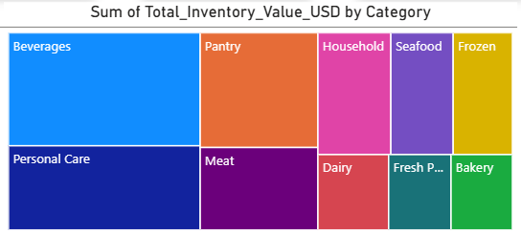

This visualization highlights which categories contribute most to total inventory value:
- Beverages and Personal Care hold the largest share of inventory value
- Categories like Frozen, Bakery, and Fresh Products contribute smaller portions
Insight: High-value categories should be prioritized for:
- Demand accuracy
- Stock optimization
- Supplier performance monitoring

Quantity on Hand by SKU & Inventory Status (Bar Chart)
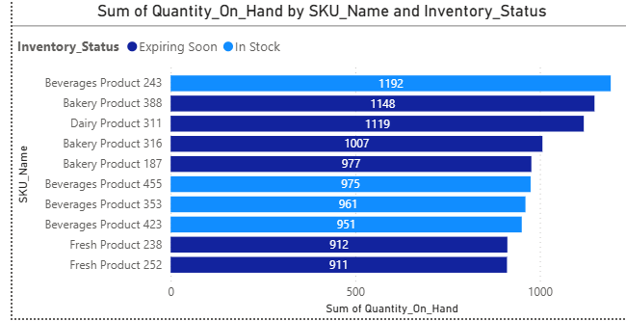

This chart displays the top SKUs with the highest stock levels, segmented by inventory status.
- Helps identify overstocked SKUs
- Shows which SKUs are In Stock vs Expiring Soon
Insight: Some high-quantity SKUs fall under Expiring Soon, indicating a risk of wastage if not managed proactively.

Supplier On-Time Performance (Bar Chart)
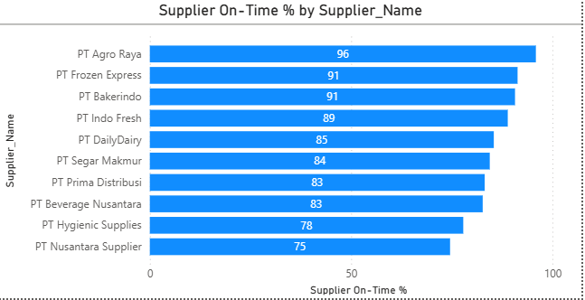
This chart compares supplier delivery performance:
- Top performers:
  - PT Agro Raya (96%)
  - PT Frozen Express (91%)
- Lower performers:
  - PT Nusantara Supplier (75%)
  - PT Hygienic Supplies (78%)
Insight: Suppliers with lower on-time percentages may contribute to inventory shortages or delays and should be reviewed.

Slicers & Interactivity
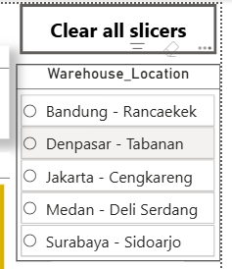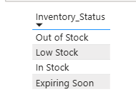

Warehouse Location Slicer
- Enables warehouse-specific analysis
- Helps compare inventory health across locations

Inventory Status Slicer
- Allows users to focus on:
  - Low Stock
  - Expiring Soon
  - Out of Stock
- Improves decision-making for urgent inventory actions

Business Recommendations
- Reduce Expiring Inventory
  - Improve FIFO (First In, First Out)/FEFO (First Expired, First Out) implementation
  - Align purchase quantities with actual demand
- Improve Forecast Accuracy
  - Review SKUs with low forecast accuracy
  - Use historical sales trends more effectively
- Strengthen Supplier Management
  - Work closely with low on-time suppliers
  - Consider alternative suppliers for critical items
- Monitor High-Value Categories
  - Apply tighter controls on beverages and personal care inventory
  - Reduce excess stock to free up working capital

Conclusion
This dashboard provides a single-page, executive-friendly view of supply chain and inventory performance. By combining KPIs, inventory distribution, supplier analysis, and interactive filters, it supports data-driven decisions to improve efficiency, reduce risk, and optimize inventory levels.

